

Aero-acoustic experimental identification of feedback mechanisms DUE TO HVAC COMPONENTS

JM. Ville1*, S. Bennouna2, N. Papaxanthos1, E. Perrey-Debain1 and S. Moreau1

1Laboratoire Roberval UMR CNRS 7337

Sorbonne Universités, Université de Technologie de Compiègne

CS 60319, 60203 Compiègne, France

Email: jean-michel.ville@utc.fr, emmanuel.perrey-debain@utc.fr

2Valeo Thermal Systems

8 rue Louis Lormand, 78320 La Verrière, France

Email: [saad.bennouna@valeo.com](mailto:saad.bennouna@valeo.com)

ABSTRACT

The Heating Ventilation and Air Conditioning (HVAC) system of a car has to provide air flow to ensure the passengers comfort regarding the temperature inside the vehicle cabin without damaging the acoustic environment. The acoustic sources are mainly produced by the blower and by the interaction between a low Mach number flow and the elements located in a duct. A research program CEVAS was conducted under the leadership of Valeo to develop a tool to design low noise car HVAC. The acoustic laboratory of the University of Technology of Compiègne (UTC) was in charge of the experimental and theoretical characterization of the aeroacoustics sources. With the experimental 2N-ports method, measurements of the scattering matrix and of the aero-acoustic power spectrum of the aero-acoustic sources are performed. The existence of fluid-resonant feedback mechanisms responsible for high level tones radiated sound power are identified and discussed for a butterfly flap and two diaphragms in tandem, the latter representing the association of HVAC elements.

1. INTRODUCTION

To obtain a satisfactory indoor environment, the acoustical design of a ventilation system HVAC is as important as its thermal design becoming even more significant since the development of the electrical and hybrid electric vehicles. The HVAC noise is in part caused by the turbulent low Mach number flow interactions with multiple in-duct discontinuities (flaps, filter, heat exchanger, bends…) located in a compact housing duct. To predict the Sound Power Level (SWL) spectra of these aero-acoustic sources usually the Nelson-Morfey’s theory [1] which assumes a dipole source distribution resulting of the drag fluctuating forces arising from the turbulent flow in the vicinity of the element was used leading to typical broadband spectra. However, several experimental works have pointed out amplifications and whistling effects in a car HVAC [2,3] which are shown to be produced by fluid-acoustic interaction. Indeed, basically, there are three different mechanisms which generate upstream feedback of disturbance [4]: structural vibrations, fluid-resonant mechanism triggered when the frequency of vorticity shedding becomes close to that of an acoustic resonator and the fluid-dynamic mechanismcaused by flow impingement on a downstream object. The aim of this paper is to point out experimentally that the coupling between flow instability and an upstream feedback can be responsible for noise amplifications. Two scenarios representing the association of HVAC elements are investigated: a butterfly flap and and two diaphragms in tandem.

1. The 2N-ports method procedure and harware

To characterize the aero-acoustic source, experiments are performed assuming that each tested element is located in a hard wall straight duct H=0.1m high and W=0.2m width rectangular cross section (Figure 1).

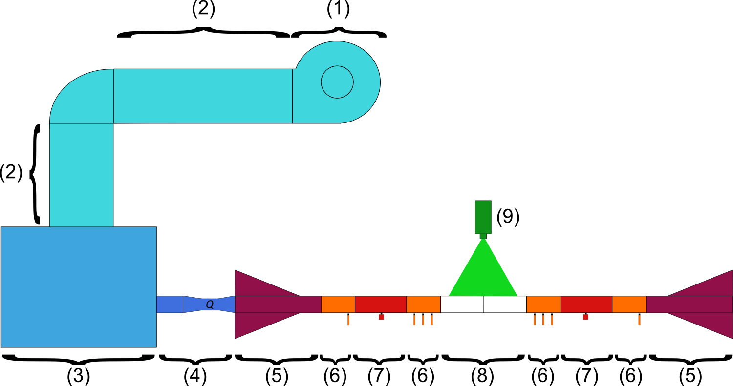 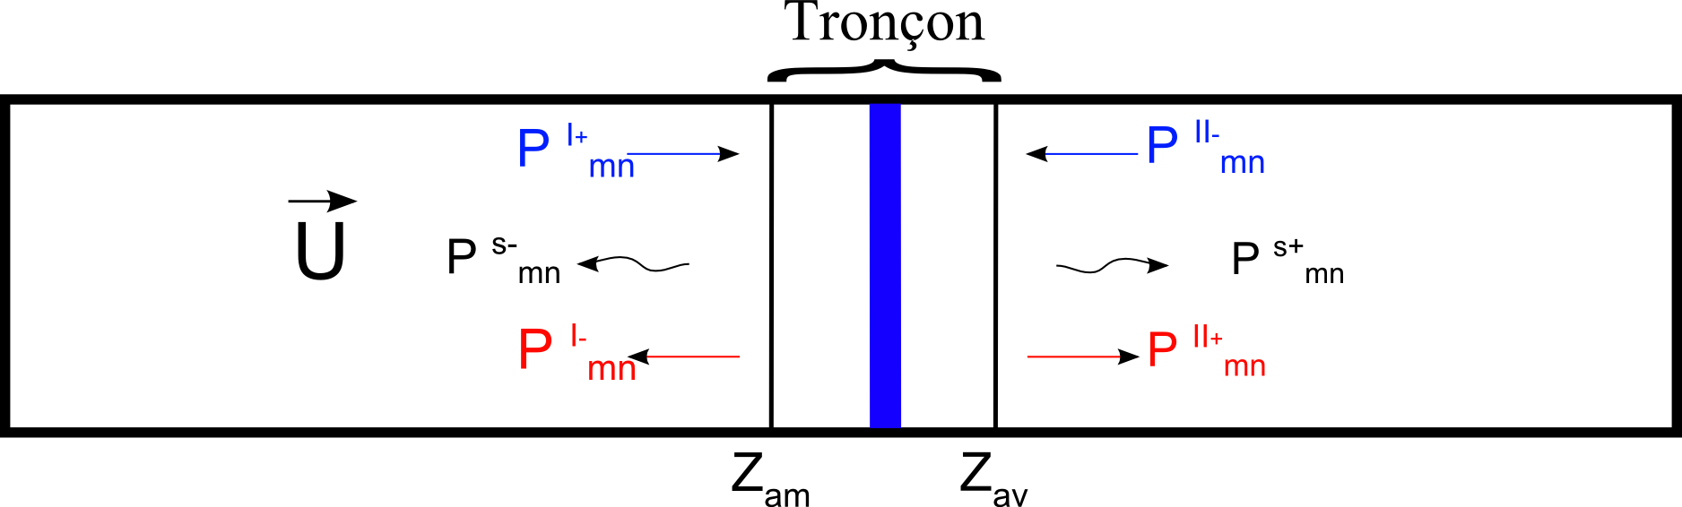

Figure 1: Duct flow facility hardware and the 2N-ports representation.

The acoustic waves ${\left\{P^{so}\right\}}_{2N}$ coming out downstream and upstream of the test section are related to the incoming pressures ${\left\{P^{en}\right\}}_{2N}$ and to the acoustic pressure ${\left\{P^{s}\right\}}_{2N}$ produced by a source located in the test section by a 2N ports formulation [5]:

|  |  |
| --- | --- |
| ${\left\{P^{so}\right\}}_{2N} = {\left[S\right]}_{2N×2N}×{\left\{P^{en}\right\}}_{2N} +{\left\{P^{s}\right\}}_{2N}$ |  |

where ${\left[S\right]}_{2N×2N}$ is the scattering matrix of the test section and U is the mean velocity of the flow The aim of the experiment is to measure the scattering matrix and the source vector ${\left\{P^{s}\right\}}_{2N}$ up to 3500Hz where N=8 modes of the rectangular duct are cut-on. The duct flow facility and the experimental procedure are detailed in [5].

1. presentation of the elements and configurations tested

The two diaphragms in tandem and the flap are shown in Figure 2. Measurements are conducted for mean flow velocities from 1.7 up to 7m/s, three distances L (0.06, 0.13, 0.21m) between the two diaphragms and flap angles α is varying from nearly closed 15° up to horizontal position 90°.

** 

Figure 2: The two diaphragms in tandem and the flap in the test section.

1. Results
   1. Diaphragms in tandem

The total SWL radiated by the aero-acoustic source for the three values of L are compared with the SWL of a single diaphragm for a mean flow velocity U=6.95m/s (Figure 3).

**

Figure 3: SWL for a single diaphragm (black) and a tandem with L=0.06m (pink), 0.13m (blue) and L=0.21m (green).

With the tandem the broadband noise is increased by more than 20dB with the presence of peaks at low frequencies. A good agreement is found between the tones and the Rossiter’s frequencies [6] which depend upon U and L as given by the relationship:

$$f_{n}=\frac{n-ε}{L\left(\frac{1}{U_{c}}+\frac{1}{c_{0}}\right)}$$

where n is the number of vortices, Uc is the convection velocity of the vortex, ε=0.25 is an empirical constant and c0 is the speed of sound. These frequencies are the result of a feedback effect produced by the vortices impingement on the second diaphragm causing acoustic waves propagating upstream and triggering a new set of vortices.

* 1. Butterfly flap

The total upstream and downstream SWL radiated by the flap for three mean flow velocities are plotted in Figure 4 pointing out that around 2500Hz the SWL is higher than the SWL for higher flow velocities. This phenomenon is due to the feedback effect between the vortex frequency produced by the flow interacting with the flap and the acoustic β-Parker’s mode [7] of the quasi-trapped mode of the cavity around the flap which the resonance frequency was calculated for an horizontal plate [8].

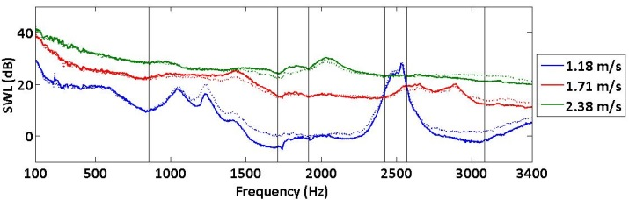

Figure 4: SWL radiated downstream (-) and upstream (···) of the flap for α = 30°.

1. CONCLUDING REMARKS

Two kinds of feedback effects caused by the interaction of a low Mach number flow in a duct with a butterfly flap and with two nearby elements have been experimentally observed. It has been shown that they are produced respectively by the coincidence between the plate vortex shedding frequency with the quasi-trapped mode of the cavity around the flap and by the flow impingement on a downstream solid object. This work shows that during the design process of a car HVAC these two physical phenomena have to be taken into account to avoid high level and whistling noise.

**Acknowledgments**

The authors are grateful to the Région Picardie and the FEDER for their financial support.

References

1. P. Nelson and C. Morfey, “Aerodynamic sound production in low speed flow ducts,” Journal of Sound and Vibration, vol. 79, pp. 263-289, 1981.
2. J. Kreuzinger, F. Schwertfirm, N. Peller and M. Hartmann, “Analysis of resonance phenomena caused by obstacles in HVAC exhaust nozzles using CFD-CAA approach”, AIAA paper 2132, 19th AIAA Aeroacoustics conference (Berlin,Germany), 2013.
3. S. Guérin, E. Thomy and M. Wright, “Aeroacoustics of automotive vents”, Journal of Sound and Vibration, vol. 285, pp. 859-875, 2004.
4. S. Ziada, “Industrial aeroacoustics: excitation mechanisms and counter-measures”. IV Escola de Primavera de Transição e Turbulência, 2004
5. S. Bennouna and all, “Aeroacoustic Prediction Methods of Automotive HVAC Noise,” SAE Noise & Vibration Conference (Grand Rapids, USA), 2015.
6. JE Rossiter, “Wind tunnel experiments on the flow over rectangular cavities at subsonic and transonic speeds”, Aeronautical Research Council Report and Memorandum N° 3438 1964
7. R. Parker, “Resonance effects in wake shedding from parallel plates: calculation of resonant frequencies”, Journal of Sound and Vibration, vol. 5(2), pp. 330-343, 1967.
8. W. Koch, “Resonance acoustic frequencies of flat plate cascades”, Journal of Sound and Vibration, vol. 88(2), pp. 233-242, 1983.